|  |
| --- |
| 2020/21 |
| Softwarica College of IT & E-Commerce / Coventry University |
| Course Name: STW104KM: Enterprise Information Systems |
| Module Code: STW104KM |
| Module Name: Enterprise Information Systems |
| Instructions to candidates |
| Time allowed:2 Hours 0 minutes |
| Answer: All Questions Full Marks: 50  Pass Marks: 20  The total number of questions in this paper: 8.  Start each question **on a new page** and carefully identify your answers with the correct question number |
| For this examination you will be supplied with the following:  1 Answer Book/s |
|  |
| You must hand this question paper in at the end of the examination. |

**Question 1. What is Key difference between Agile and Waterfall Model? (5 marks)**

1. Waterfall is a Liner Sequential Life Cycle Model whereas Agile is a continuous iteration of development and testing in the software development process.
2. Agile methodology is known for its flexibility whereas Waterfall is a structured software development methodology.
3. Agile follows an incremental approach whereas the Waterfall methodology is a sequential design process.
4. Agile performs testing concurrently with software development whereas in Waterfall methodology testing comes after the “Build” phase.
5. Agile allows changes in project development requirement whereas Waterfall has no scope of changing the requirements once the project development starts.

**(1 mark for each point consider other similar point)**

**Question 2.**  An order processing system accepts different product order from customer, validate against the stock and accept the order, if product is available in stock.

Draw The Class Diagram for the Above System. **(10 marks)**

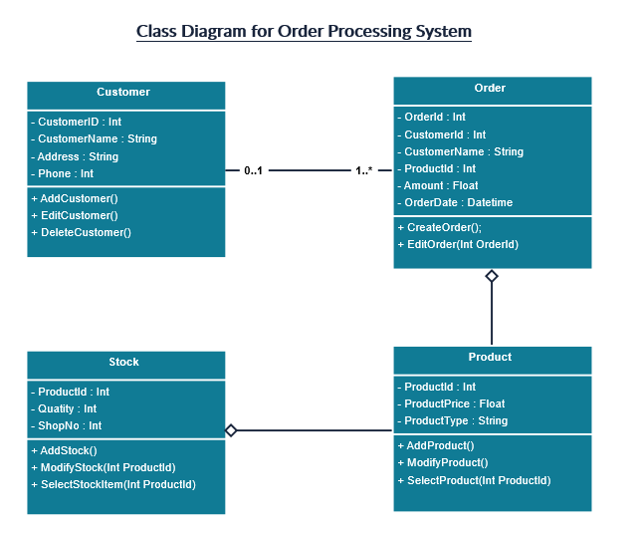

**(Maximum 10 marks, 4 marks to identified all the Entities ,4 marks for their attributes and 2 marks for relationship, provide marks for similar assumption)**

**Question 3. (10 marks)**

Her Majesty’s Coastguard operates a number of search and rescue helicopter bases located across the British coastline. A unique number identifies each search & rescue base. The address and contact number for each base are also recorded. Each base employs at least one or more senior helicopter pilots and each senior helicopter pilot belongs to only one base. A senior helicopter pilot may pilot one or more helicopters or may not pilot any helicopter. Information such as number, name, nationality and contact number are stored for each senior helicopter pilot. Each helicopter has a unique registration code, name and make. A helicopter needs at least one senior pilot to be flown. Whenever a senior pilot flies a helicopter on a rescue mission the date and location of the rescue mission associated with the helicopter flight are also recorded.

**Task 1:** identify main entities for this problem.

**Task 2:** For each entity identify the possible attributes and indicate the identifier for each entity.

**Task 3:** identify the main relationships between the entities and their cardinalities

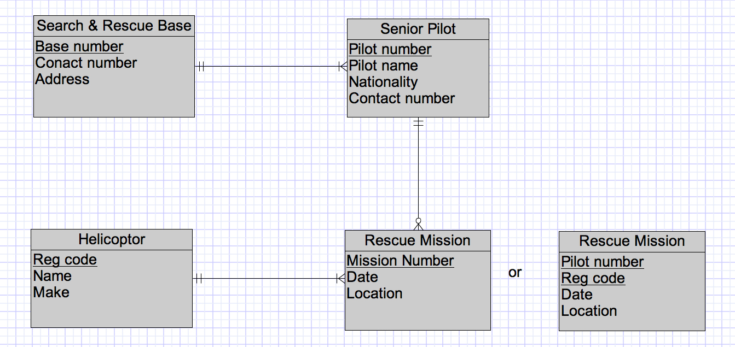

**(Maximum 10 marks, 4 marks to tak1 ,4 marks for task 2 and 2 marks for task 3, provide marks for similar assumption)**

**Question 4 (5 marks)**

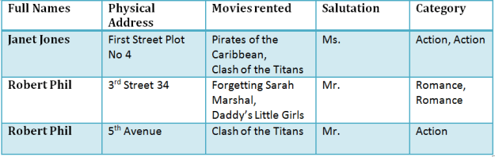

**Task1: Draw the INF of the above table.**

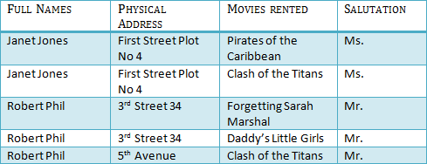

**(Maximum 5 marks, provide 5 marks for conversion of multivalued Colum Movie Rented to single value column)**

**Question 5. Define the following terms**

1. Encapsulation
2. Class
3. Object
4. Inheritance
5. Abstraction

**Encapsulation:** Data hiding and data binding. **(1 marks)**

**Class:** Blue print of object, Collection of data members and related member functions **(1 marks consider other similar definition)**

**Object**: Instance of class (1 marks **consider other similar definition**)

**Inheritance: Transferring properties of one class to another class (1 marks, consider other similar definition)**

**Abstraction:** Abstraction is the principle of generalization. This requires that we move from a specific instance to a more generalized concept by thinking about the most basic information and function of an object (**1 marks**, consider **other similar definition**)

**Question 6. Why use the Cloud? (5 marks)**

1. Start small and fast
2. Low initial costs
3. Think big, scale up
4. Flexibility, test and add features and platforms
5. Focus on product and features rather than system administrator tasks and security

**(Maximum 5 marks, 1 marks for each pint, consider similar point)**

**Question 7. Name the Types of virtualization: (marks 5)**

1. Network virtualization
2. Storage virtualization
3. Server virtualization
4. Data virtualization
5. Desktop virtualization
6. Application virtualization

**(Maximum 5 marks, 1 marks for each point, Consider for similar other point).**

**Question 8. What is ERP and What does an ERP system do?**

The ERP System is actually recording the working processes for several reasons – to collect data, to maintain flow of processes and to gain control. After documenting the processes, it facilitates transfer of data and information between the different departments in the organization**. (2 marks, consider similar definition)**

1. Allows companies to integrate core business processes, (i.e. product planning, purchasing, production, manufacturing, human resources and finance), often in REAL TIME, by software and ICT, by sharing information across business functions and employee hierarchies. (1 marks, consider similar definition)
2. Is a software application with a centralised database that is implemented across the entire organisation? (1 marks, consider similar definition)
3. Combines all databases across departments into a single database that can be accessed by all employees, and automates the tasks involved in performing a business process. (1 marks, consider similar definition)